### Employee Data Analysis using Excel

STUDENT NAME: M.RITHIKA REGISTER NO : 312211123

DEPARTMENT : B.COM (ACCOUNTING & FINANCE)

COLLEGE : DR.MGR.JANAKI COLLEGE OF ARTS & SCIENCE FOR WOMEN.

1



## PROJECT TITLE

**Employee Performance Analysis using Excel**

2

# AGENDA

3/21/2024 **Annual Review**



1. Problem Statement
2. Project Overview
3. End Users
4. Our Solution and Proposition
5. Dataset Description
6. Modelling Approach
7. Results and Discussion
8. Conclusion



3

## PROBLEM STATEMENT

A Problem statement is a tool that can be used to address employee performance issues in a timely and efficient manner.

4



## PROJECT OVERVIEW

The Primary goal of this project is to evaluate employee  performance data using excel to identify key performance metrics, Trends, and area of improvement. The analysis helps in decision-making, performance reviews, and decision employee training or reward programs.

**FEATURES:**

* Data Collection and Cleaning
* Performance metrics
* Data analysis techniques
* Visualization
* Performance comparison
* Actionable insights
* Automation

5

### WHO ARE THE END USERS?

* HR Manager



* Department manager/ Team Leader
* Senior Management/ Executives
* Employees
* Data Analysts

6

**OUR SOLUTION AND ITS VALUE PROPOSITION**

Data input template

Automated Calculations

Enhanced Insights

Improved Accuracy

**Our**

**Solution**

Visualization Dashboards

**Value**

**Proposition**

Increased Efficiency

Initial

Setup

Performance Metrics

Customization

Better Decision- Making



7

# Dataset Description

1. Employee ID
2. Employee Name 3)Department 4)Role/Position 5)Performance metrics 6)Goals/Objectives 7)Performance Score
3. Review Period
4. Manager Feedback 10)Training needs



## THE "WOW" IN OUR SOLUTION

To Create a “WOW” factor in your employee

performance solution,

consider Incorporating Innovate and engaging elements that not only present data but also Inspire and motivate your team. Here are some ideas to enhance your employee Performance analysis: Interactive Dashboards, Gamification, Visual Storytelling,

Employee Recognition Programs, feedback loops, Training and development opportunities, Regular updates and Celebrations.

9

3/21/2024 **Annual Review**

# MODELLING

10

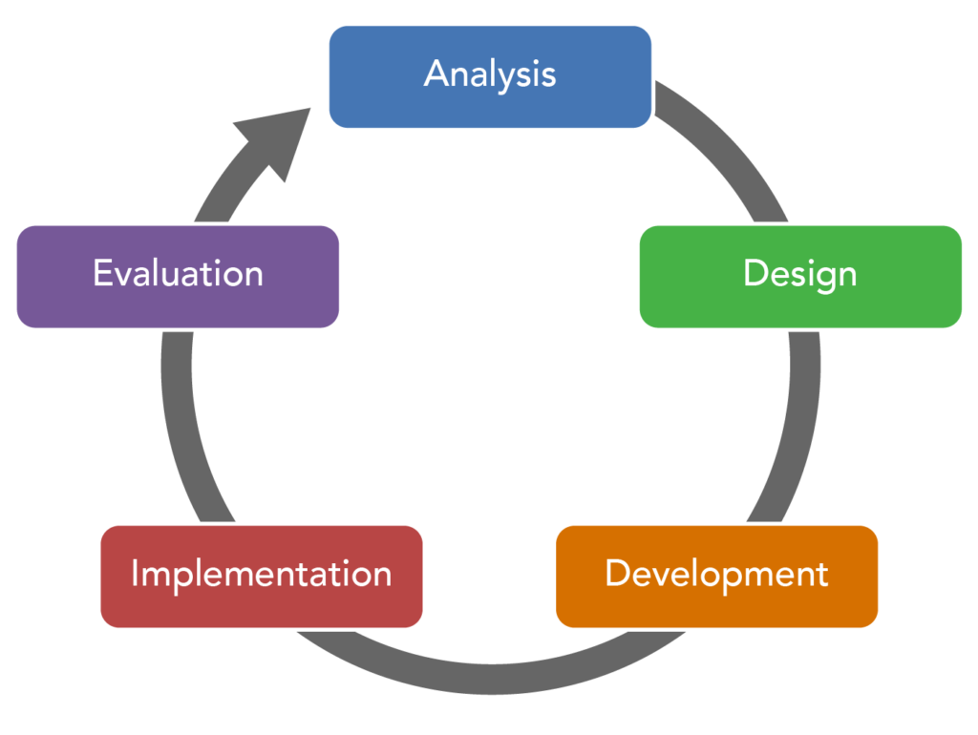

# RESULTS



Employee performance results are a way to measure and employees Effectiveness, Efficiency, and contribution to a company’s Goals.

They can help identify areas for Improvements, align efforts with organizational goals, and support data-driven decisions.

11

# conclusion

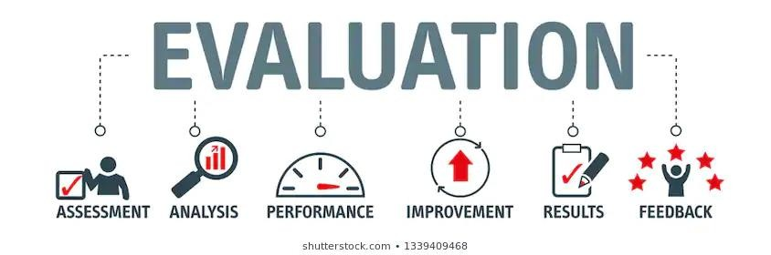

A Conclusion for an Employee performance review should summarize the employee performance, Highlights their strengths , and identify areas for improvements.